YOLO-ESCA: A High-Performance Safety Helmet Standard Wearing Behaviour Detection Model Based on Improved YOLOv5
1 INTRODUCTION
In recent years, ensuring the safety of workers, especially those in hazardous environments such as construction sites, manufacturing plants, and mining operations, has become a critical concern. One of the most fundamental safety measures for these workers is the wearing of personal protective equipment (PPE), specifically safety helmets, which are designed to protect the head from various types of injuries. Despite the implementation of safety protocols, helmet-wearing compliance remains a challenge, leading to injuries and fatalities that could have been prevented by simple adherence to safety guidelines.
The emergence of advanced technologies, such as deep learning and computer vision, has significantly contributed to the improvement of safety standards in industrial settings. One promising solution is the development of automated systems capable of monitoring and detecting whether workers are properly wearing their safety helmets. These systems not only enhance safety but also allow for real-time monitoring, ensuring compliance with safety protocols without relying on human intervention. However, creating an efficient and accurate model for detecting safety helmet-wearing behavior has proven to be a challenging task due to the complexities involved in object detection, such as varying helmet types, worker poses, environmental conditions, and occlusions.
To address these challenges, this study proposes YOLO-ESCA, a high-performance safety helmet standard wearing behavior detection model based on an improved version of YOLOv5, a state-of-the-art object detection algorithm. YOLOv5, a member of the "You Only Look Once" family of models, has demonstrated remarkable performance in real-time object detection tasks due to its speed and accuracy. However, while it excels in many general detection tasks, there are still significant opportunities for improvement, especially when applied to safety helmet detection in complex industrial environments.
The YOLO-ESCA model builds upon the foundational strengths of YOLOv5 and introduces several key enhancements tailored specifically for the task of detecting safety helmet-wearing behaviors. These enhancements include the integration of novel techniques for improving detection accuracy under occlusions and varying lighting conditions, as well as optimizing the model for real-time performance, which is crucial for deployment in dynamic industrial environments. The modified YOLOv5 architecture incorporates specialized feature extraction layers, better handling of multiple worker poses, and more robust training strategies to adapt to diverse environments.
The primary objective of YOLO-ESCA is to provide a reliable, real-time solution for detecting whether workers are wearing safety helmets in accordance with established safety standards. By leveraging the power of deep learning and computer vision, YOLO-ESCA aims to offer automated, scalable, and efficient monitoring of safety compliance, ultimately reducing the risk of head injuries and fatalities in workplaces.
Furthermore, the proposed model is designed to be scalable and adaptable to a wide range of industrial scenarios. This flexibility is essential for industries with varying environmental conditions and worker behaviors. The ability to accurately detect safety helmet usage across different work sites is a key feature of YOLO-ESCA, enabling organizations to implement this solution without needing significant modifications or retraining. The model’s real-time capabilities make it particularly suitable for deployment in surveillance systems, where continuous monitoring is required to ensure ongoing safety compliance.
In this paper, we provide a detailed description of the YOLO-ESCA model, outlining its architecture, improvements over the original YOLOv5, and its application in safety helmet-wearing behavior detection. Additionally, we present experimental results demonstrating the effectiveness of YOLO-ESCA in a variety of real-world scenarios. Through these results, we show that the proposed model outperforms traditional object detection methods in terms of accuracy, detection speed, and robustness, thereby making a significant contribution to the field of industrial safety and automation.
Ultimately, the development of YOLO-ESCA represents a step forward in utilizing AI-based solutions to improve workplace safety, providing organizations with a powerful tool to reduce human error and enforce safety regulations more effectively. By automating the detection of helmet-wearing behaviors, YOLO-ESCA aims to foster a safer, more compliant work environment, contributing to the protection of workers and the prevention of preventable injuries and fatalities.
2. LITERATURE SURVEY
"YOLOv5: Overview and Improvements for Object Detection" In this study, researchers analyze the performance of YOLOv5 in object detection tasks. They highlight improvements in speed and accuracy over previous YOLO versions, making it a suitable candidate for real-time applications, such as safety helmet detection. YOLOv5's ability to balance high detection rates with low latency is crucial in industrial environments, where fast and accurate decision-making is required. However, the study also identifies potential issues in detection accuracy under challenging conditions like occlusions and varied lighting, areas that need further enhancement for helmet-wearing detection.
"Real-Time Detection of Safety Equipment in Industrial Environments Using Deep Learning" This paper explores various deep learning-based solutions for detecting personal protective equipment (PPE) in industrial environments, with a focus on safety helmets. The authors discuss different approaches, including the use of convolutional neural networks (CNNs) and transfer learning techniques. They argue that real-time detection is essential for monitoring PPE usage on construction sites and manufacturing plants. While various models are evaluated, the paper concludes that real-time performance is often compromised by the environmental complexities, such as workers' movement and occlusions.
"A Review of Computer Vision Techniques for PPE Detection" This comprehensive review delves into computer vision methodologies applied to PPE detection in industrial settings. The paper covers traditional techniques like image segmentation and feature-based methods, as well as modern deep learning-based approaches. The authors conclude that deep learning models, especially convolutional neural networks (CNNs), provide superior accuracy over traditional methods but are sensitive to issues like pose variations, occlusions, and scale differences in detecting helmets.
"Improved Helmet Detection in Construction Sites Using YOLOv3 and YOLOv4" Focusing on the detection of safety helmets on construction sites, this paper compares YOLOv3 and YOLOv4 in terms of accuracy, speed, and robustness under real-world conditions. The study reports that YOLOv4 offers better performance than YOLOv3 in terms of both precision and recall, but it still struggles with detecting helmets under extreme lighting or when workers are wearing other PPE that obscures the helmet. This highlights the need for further optimization, which could be addressed by improvements such as those proposed in YOLO-ESCA.
"Pose Estimation and Helmet Detection for Worker Safety Monitoring" This study explores the combination of pose estimation algorithms and helmet detection techniques to enhance the monitoring of worker safety. The authors argue that understanding the worker’s pose can significantly improve helmet detection, especially in dynamic environments. Pose information helps mitigate challenges such as occlusion or partial visibility of the helmet, a limitation in conventional object detection models like YOLOv5. This research supports the idea that combining pose estimation with YOLOv5 could further improve detection accuracy in helmet-wearing behavior monitoring.
"Real-Time Worker Safety Compliance Monitoring Using AI and Computer Vision" The paper discusses the use of artificial intelligence (AI) and computer vision technologies to monitor worker safety compliance, focusing on real-time detection of helmets, gloves, and other PPE. YOLO-based models, including YOLOv3 and YOLOv4, are evaluated for their performance in various industrial settings. The study identifies the potential for YOLO models to scale for large deployment but notes that issues like false positives/negatives and real-time processing constraints remain challenges to be overcome.
"Helmet Detection in Construction Environments Using Transfer Learning Techniques" This research investigates the use of transfer learning for helmet detection in construction environments. By leveraging pre-trained models like ResNet and Inception, the study finds that transfer learning can improve detection accuracy, especially when there is limited training data. The paper discusses the impact of environmental factors, such as background clutter and varying lighting conditions, and suggests that improvements in transfer learning approaches, combined with fine-tuned YOLO models, could offer a more reliable solution for safety helmet detection.
"Helmet Detection for Worker Safety Using Deep Neural Networks: Challenges and Future Directions" This paper focuses on the challenges in developing accurate helmet detection models using deep neural networks (DNNs). The authors highlight the difficulties posed by varied worker poses, occlusions, and environmental factors, and suggest that future improvements should focus on enhancing DNN architectures to handle these complexities. The paper also suggests integrating data augmentation techniques, multi-task learning, and ensemble methods to improve the robustness of detection models for helmet-wearing behavior monitoring.
"Enhancing Real-Time Detection for PPE Compliance in Industrial Settings" This study examines the limitations of current real-time PPE compliance monitoring systems, including the use of traditional image processing methods and basic deep learning models. The authors discuss how advanced models like YOLOv5, combined with enhanced detection pipelines, can overcome issues such as occlusion, background clutter, and low-light conditions. The paper suggests that YOLOv5 could be optimized for helmet detection by improving its feature extraction layers and implementing adaptive training strategies to deal with real-world industrial conditions.
"Adapting YOLO Models for PPE Detection in Challenging Environments: A Case Study" This paper presents a case study where YOLO-based models were adapted to detect PPE, specifically safety helmets, in highly challenging industrial environments. The study addresses issues like cluttered backgrounds, occlusions, and irregular helmet designs, proposing the use of modified YOLO architectures that are tailored for specific industrial conditions. The research concludes that by modifying YOLO's anchor box configurations, loss functions, and training datasets, real-time detection accuracy can be significantly improved, which aligns with the goals of YOLO-ESCA for safety helmet monitoring.

3 .SYSTEM ANALYSIS
3.1 Existing System
Existing systems for safety helmet detection typically rely on traditional computer vision techniques or basic deep learning models to identify whether workers are wearing helmets in industrial or construction environments. These systems often use pre-trained convolutional neural networks (CNNs) or simpler object detection models, which may struggle with accuracy in complex scenarios such as varying lighting conditions, different helmet styles, or occlusions. Some models use YOLO (You Only Look Once) algorithms for real-time detection, but they may not offer sufficient precision or speed in handling the diverse and dynamic nature of worker behaviors. While existing systems address the problem of detecting helmet usage, they often face limitations in handling the diverse challenges of real-world applications, prompting the need for improved models that balance accuracy, robustness, and performance.
Disadvantages
- Less accuracy
- Security is less.
3.2 PROPOSED SYSTEM
The proposed YOLO-ESCA system enhances the YOLOv5 architecture to create a high-performance, real-time safety helmet detection model that is specifically designed to accurately monitor workers' helmet-wearing behavior in dynamic industrial environments. YOLO-ESCA incorporates advanced improvements such as better feature extraction, optimized data augmentation, and an adjusted loss function to improve the model’s accuracy in detecting helmets under challenging conditions like occlusions, varying light, and diverse helmet types. By leveraging a more diverse and comprehensive dataset, the system reduces false positives and false negatives, ensuring higher precision and reliability. Additionally, the model is optimized to maintain high performance and real-time processing capabilities, making it suitable for large-scale safety monitoring in industrial settings.
Advantages
- High accuracy
- Security is high
3.3. PROCESS MODEL USED WITH JUSTIFICATION
SDLC (Umbrella Model):
Umbrella Activity
Umbrella Activity
Umbrella Activity
- Feasibility Study
- TEAM FORMATION
- Project Specification PREPARATION

Business Requirement Documentation
ANALYSIS & DESIGN
CODE
UNIT TEST
DOCUMENT CONTROL

ASSESSMENT

TRAINING
INTEGRATION & SYSTEM TESTING

DELIVERY/INSTALLATION
ACCEPTANCE TEST
Requirements Gathering
SDLC is nothing but Software Development Life Cycle. It is a standard which is used by software industry to develop good software.
Stages in SDLC:
- Requirement Gathering
- Analysis
- Designing
- Coding
- Testing
- Maintenance

Requirements Gathering stage:
The requirements gathering process takes as its input the goals identified in the high-level requirements section of the project plan. Each goal will be refined into a set of one or more requirements. These requirements define the major functions of the intended application, define operational data areas and reference data areas, and define the initial data entities. Major functions include critical processes to be managed, as well as mission critical inputs, outputs and reports. A user class hierarchy is developed and associated with these major functions, data areas, and data entities. Each of these definitions is termed a Requirement. Requirements are identified by unique requirement identifiers and, at minimum, contain a requirement title and textual description.
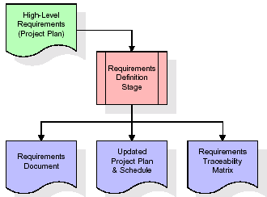
These requirements are fully described in the primary deliverables for this stage: the Requirements Document and the Requirements Traceability Matrix (RTM). The requirements document contains complete descriptions of each requirement, including diagrams and references to external documents as necessary. Note that detailed listings of database tables and fields are not included in the requirements document.
The title of each requirement is also placed into the first version of the RTM, along with the title of each goal from the project plan. The purpose of the RTM is to show that the product components developed during each stage of the software development lifecycle are formally connected to the components developed in prior stages.
In the requirements stage, the RTM consists of a list of high-level requirements, or goals, by title, with a listing of associated requirements for each goal, listed by requirement title. In this hierarchical listing, the RTM shows that each requirement developed during this stage is formally linked to a specific product goal. In this format, each requirement can be traced to a specific product goal, hence the term requirements traceability.
The outputs of the requirements definition stage include the requirements document, the RTM, and an updated project plan.
- Feasibility study is all about identification of problems in a project.
- No. of staff required to handle a project is represented as Team Formation, in this case only modules are individual tasks will be assigned to employees who are working for that project.
- Project Specifications are all about representing of various possible inputs submitting to the server and corresponding outputs along with reports maintained by administrator.
Analysis Stage:
The planning stage establishes a bird's eye view of the intended software product, and uses this to establish the basic project structure, evaluate feasibility and risks associated with the project, and describe appropriate management and technical approaches.
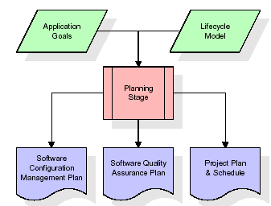
The most critical section of the project plan is a listing of high-level product requirements, also referred to as goals. All of the software product requirements to be developed during the requirements definition stage flow from one or more of these goals. The minimum information for each goal consists of a title and textual description, although additional information and references to external documents may be included. The outputs of the project planning stage are the configuration management plan, the quality assurance plan, and the project plan and schedule, with a detailed listing of scheduled activities for the upcoming Requirements stage, and high level estimates of effort for the out stages.
Designing Stage:
The design stage takes as its initial input the requirements identified in the approved requirements document. For each requirement, a set of one or more design elements will be produced as a result of interviews, workshops, and/or prototype efforts. Design elements describe the desired software features in detail, and generally include functional hierarchy diagrams, screen layout diagrams, tables of business rules, business process diagrams, pseudo code, and a complete entity-relationship diagram with a full data dictionary. These design elements are intended to describe the software in sufficient detail that skilled programmers may develop the software with minimal additional input.

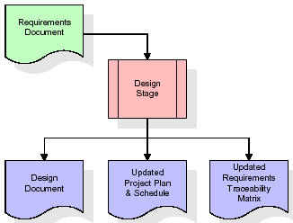
When the design document is finalized and accepted, the RTM is updated to show that each design element is formally associated with a specific requirement. The outputs of the design stage are the design document, an updated RTM, and an updated project plan.
Development (Coding) Stage:
The development stage takes as its primary input the design elements described in the approved design document. For each design element, a set of one or more software artifacts will be produced. Software artifacts include but are not limited to menus, dialogs, and data management forms, data reporting formats, and specialized procedures and functions. Appropriate test cases will be developed for each set of functionally related software artifacts, and an online help system will be developed to guide users in their interactions with the software.
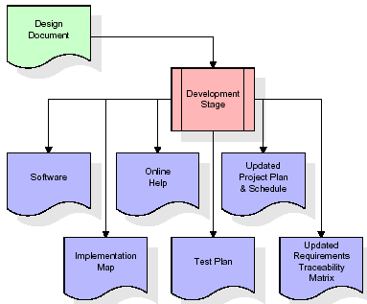

The RTM will be updated to show that each developed artifact is linked to a specific design element, and that each developed artifact has one or more corresponding test case items. At this point, the RTM is in its final configuration. The outputs of the development stage include a fully functional set of software that satisfies the requirements and design elements previously documented, an online help system that describes the operation of the software, an implementation map that identifies the primary code entry points for all major system functions, a test plan that describes the test cases to be used to validate the correctness and completeness of the software, an updated RTM, and an updated project plan.
Integration & Test Stage:
During the integration and test stage, the software artifacts, online help, and test data are migrated from the development environment to a separate test environment. At this point, all test cases are run to verify the correctness and completeness of the software. Successful execution of the test suite confirms a robust and complete migration capability. During this stage, reference data is finalized for production use and production users are identified and linked to their appropriate roles. The final reference data (or links to reference data source files) and production user list are compiled into the Production Initiation Plan.
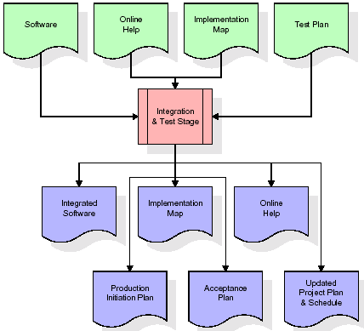
The outputs of the integration and test stage include an integrated set of software, an online help system, an implementation map, a production initiation plan that describes reference data and production users, an acceptance plan which contains the final suite of test cases, and an updated project plan.
- Installation & Acceptance Test:
During the installation and acceptance stage, the software artefacts, online help, and initial production data are loaded onto the production server. At this point, all test cases are run to verify the correctness and completeness of the software. Successful execution of the test suite is a prerequisite to acceptance of the software by the customer.
After customer personnel have verified that the initial production data load is correct and the test suite has been executed with satisfactory results, the customer formally accepts the delivery of the software.
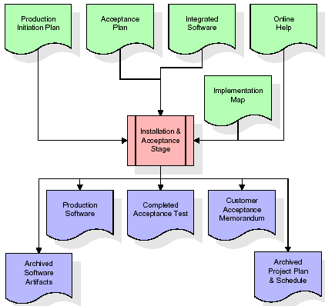
The primary outputs of the installation and acceptance stage include a production application, a completed acceptance test suite, and a memorandum of customer acceptance of the software. Finally, the PDR enters the last of the actual labour data into the project schedule and locks the project as a permanent project record. At this point the PDR "locks" the project by archiving all software items, the implementation map, the source code, and the documentation for future reference.
Maintenance:
Outer rectangle represents maintenance of a project, Maintenance team will start with requirement study, understanding of documentation later employees will be assigned work and they will undergo training on that particular assigned category. For this life cycle there is no end, it will be continued so on like an umbrella (no ending point to umbrella sticks).
3.4. Software Requirement Specification
3.4.1. Overall Description
A Software Requirements Specification (SRS) – a requirements specification for a software system is a complete description of the behaviour of a system to be developed. It includes a set of use cases that describe all the interactions the users will have with the software. In addition to use cases, the SRS also contains non-functional requirements. Non-functional requirements are requirements which impose constraints on the design or implementation (such as performance engineering requirements, quality standards, or design constraints).
System requirements specification: A structured collection of information that embodies the requirements of a system. A business analyst, sometimes titled system analyst, is responsible for analyzing the business needs of their clients and stakeholders to help identify business problems and propose solutions. Within the systems development lifecycle domain, the BA typically performs a liaison function between the business side of an enterprise and the information technology department or external service providers. Projects are subject to three sorts of requirements:
- Business requirements describe in business terms what must be delivered or accomplished to provide value.
- Product requirements describe properties of a system or product (which could be one of several ways to accomplish a set of business requirements.)
- Process requirements describe activities performed by the developing organization. For instance, process requirements could specify .Preliminary investigation examine project feasibility, the likelihood the system will be useful to the organization. The main objective of the feasibility study is to test the Technical, Operational and Economical feasibility for adding new modules and debugging old running system. All system is feasible if they are unlimited resources and infinite time. There are aspects in the feasibility study portion of the preliminary investigation:

- ECONOMIC FEASIBILITY
A system can be developed technically and that will be used if installed must still be a good investment for the organization. In the economical feasibility, the development cost in creating the system is evaluated against the ultimate benefit derived from the new systems. Financial benefits must equal or exceed the costs. The system is economically feasible. It does not require any addition hardware or software. Since the interface for this system is developed using the existing resources and technologies available at NIC, There is nominal expenditure and economical feasibility for certain.
- Operational Feasibility
Proposed projects are beneficial only if they can be turned out into information system. That will meet the organization’s operating requirements. Operational feasibility aspects of the project are to be taken as an important part of the project implementation. This system is targeted to be in accordance with the above-mentioned issues. Beforehand, the management issues and user requirements have been taken into consideration. So there is no question of resistance from the users that can undermine the possible application benefits. The well-planned design would ensure the optimal utilization of the computer resources and would help in the improvement of performance status.
- TECHNICAL FEASIBILITY
Earlier no system existed to cater to the needs of ‘Secure Infrastructure Implementation System’. The current system developed is technically feasible. It is a web based user interface for audit workflow at NIC-CSD. Thus it provides an easy access to .the users. The database’s purpose is to create, establish and maintain a workflow among various entities in order to facilitate all concerned users in their various capacities or roles. Permission to the users would be granted based on the roles specified. Therefore, it provides the technical guarantee of accuracy, reliability and security.
3.4.2. External Interface Requirements
User Interface
The user interface of this system is a user friendly python Graphical User Interface.
Hardware Interfaces
The interaction between the user and the console is achieved through python capabilities.
Software Interfaces
The required software is python.
HARDWARE REQUIREMENTS:

Processor - Intel i3(min)
- Speed - 1.1 Ghz
- RAM - 4GB(min)
- Hard Disk - 500 GB
- Key Board - Standard Windows Keyboard
- Mouse - Two or Three Button Mouse
- Monitor - SVGA
SOFTWARE REQUIREMENTS:
- Operating System - Windows10(min)
Programming Language - Python 3.7.0
4. SYSTEM DESIGN
UML Diagram:
Class Diagram:
The class diagram is the main building block of object oriented modeling. It is used both for general conceptual modeling of the systematic of the application, and for detailed modeling translating the models into programming code. Class diagrams can also be used for data modeling. The classes in a class diagram represent both the main objects, interactions in the application and the classes to be programmed. In the diagram, classes are represented with boxes which contain three parts:
- The upper part holds the name of the class
- The middle part contains the attributes of the class
- The bottom part gives the methods or operations the class can take or undertake
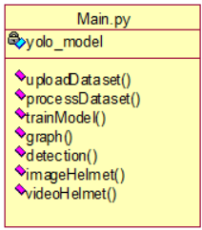

Use case Diagram:
A use case diagram at its simplest is a representation of a user's interaction with the system and depicting the specifications of a use case. A use case diagram can portray the different types of users of a system and the various ways that they interact with the system. This type of diagram is typically used in conjunction with the textual use case and will often be accompanied by other types of diagrams as well.

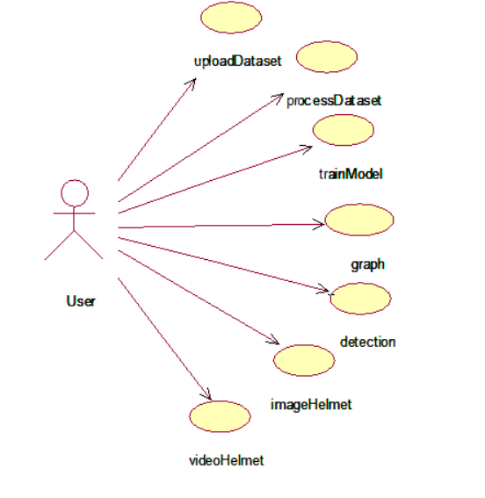
Sequence diagram:
A sequence diagram is a kind of interaction diagram that shows how processes operate with one another and in what order. It is a construct of a Message Sequence Chart. A sequence diagram shows object interactions arranged in time sequence. It depicts the objects and classes involved in the scenario and the sequence of messages exchanged between the objects needed to carry out the functionality of the scenario. Sequence diagrams are typically associated with use case realizations in the Logical View of the system under development. Sequence diagrams are sometimes called event diag rams, event scenarios, and timing diagrams
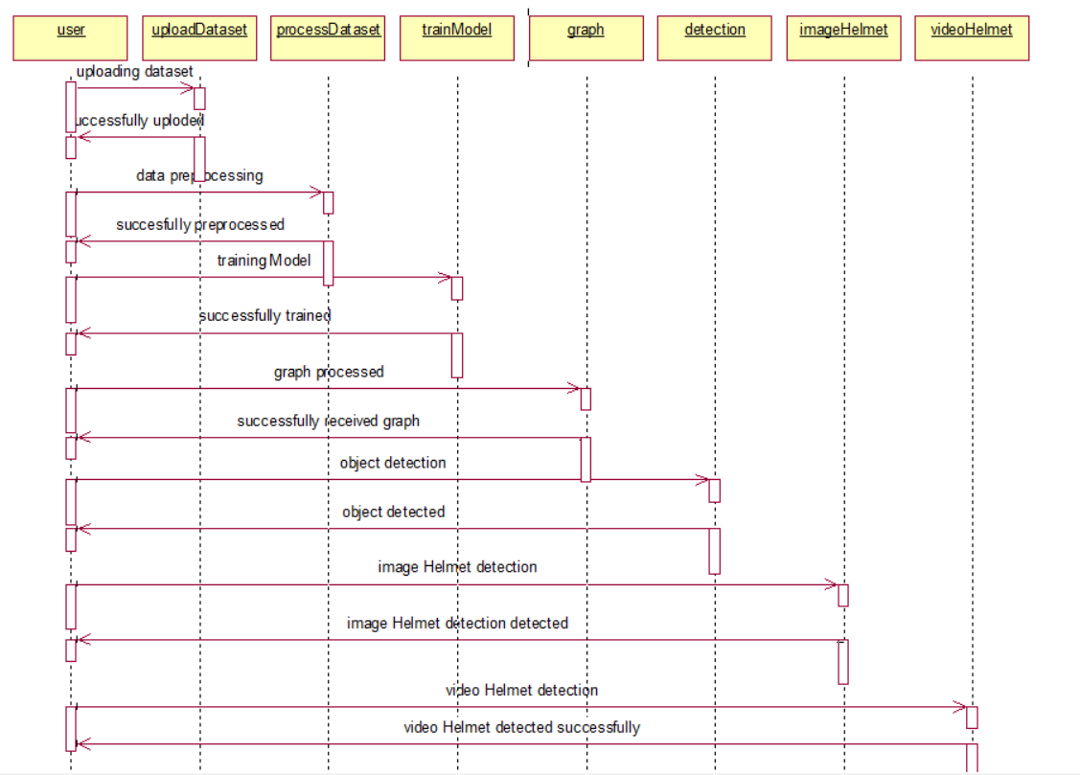

Collaboration diagram:
A collaboration diagram describes interactions among objects in terms of sequenced messages. Collaboration diagrams represent a combination of information taken from class, sequence, and use case diagrams describing both the static structure and dynamic behaviour of a system.

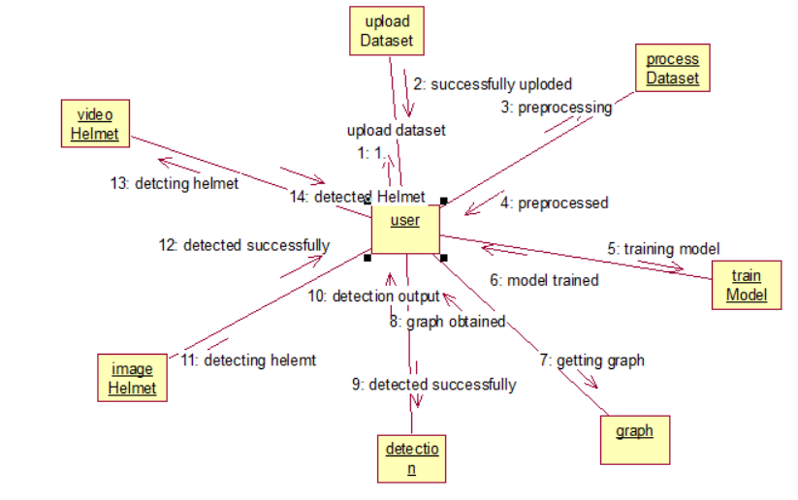
Component Diagram:
In the Unified Modelling Language, a component diagram depicts how components are wired together to form larger components and or software systems. They are used to illustrate the structure of arbitrarily complex systems.
Components are wired together by using an assembly connector to connect the required interface of one component with the provided interface of another component. This illustrates the service consumer - service provider relationship between the two components
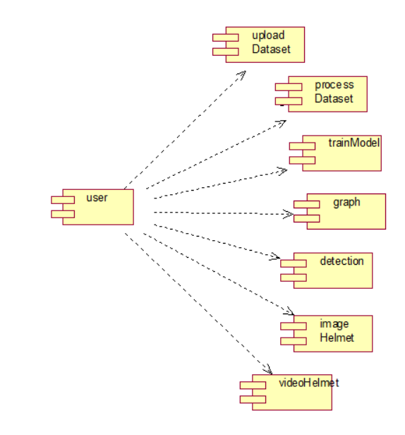

Deployment Diagram:
A deployment diagram in the Unified Modeling Language models the physical deployment of artifacts on nodes. To describe a web site, for example, a deployment diagram would show what hardware components ("nodes") exist (e.g., a web server, an application server, and a database server), what software components ("artifacts") run on each node (e.g., web application, database), and how the different pieces are connected (e.g. JDBC, REST, RMI).
The nodes appear as boxes, and the artifacts allocated to each node appear as rectangles within the boxes. Nodes may have sub nodes, which appear as nested boxes. A single node in a deployment diagram may conceptually represent multiple physical nodes, such as a cluster of database servers.

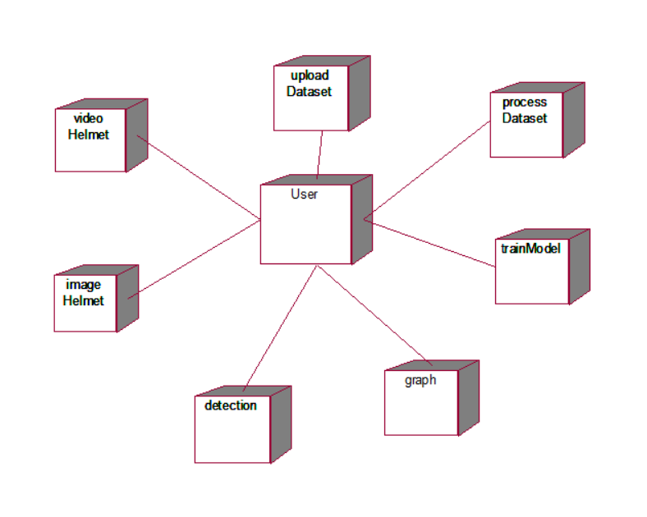

Activity Diagram:
Activity diagram is another important diagram in UML to describe dynamic aspects of the system. It is basically a flow chart to represent the flow form one activity to another activity. The activity can be described as an operation of the system. So the control flow is drawn from one operation to another. This flow can be sequential, branched or concurrent
Activity Diagram:
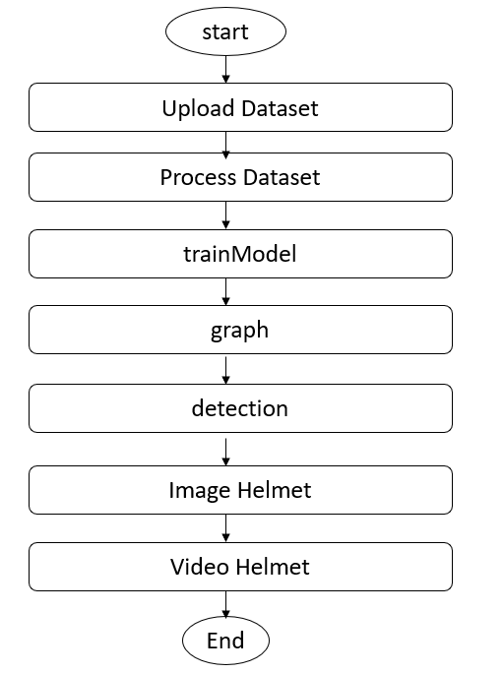

Data Flow Diagram:
Data flow diagrams illustrate how data is processed by a system in terms of inputs and outputs. Data flow diagrams can be used to provide a clear representation of any business function. The technique starts with an overall picture of the business and continues by analyzing each of the functional areas of interest. This analysis can be carried out in precisely the level of detail required. The technique exploits a method called top-down expansion to conduct the analysis in a targeted way.
As the name suggests, Data Flow Diagram (DFD) is an illustration that explicates the passage of information in a process. A DFD can be easily drawn using simple symbols. Additionally, complicated processes can be easily automated by creating DFDs using easy-to-use, free downloadable diagramming tools. A DFD is a model for constructing and analyzing information processes. DFD illustrates the flow of information in a process depending upon the inputs and outputs. A DFD can also be referred to as a Process Model. A DFD demonstrates business or technical process with the support of the outside data saved, plus the data flowing from the process to another and the end results.
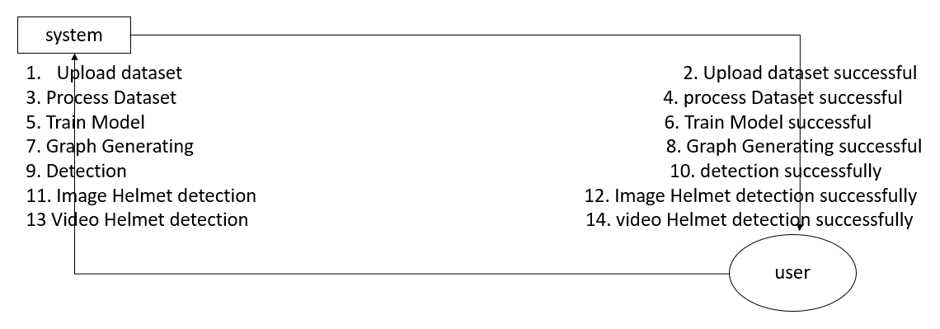
5.IMPLEMETATION
5.1 Python
Python is a general-purpose language. It has wide range of applications from Web development (like: Django and Bottle), scientific and mathematical computing (Orange, SymPy, NumPy) to desktop graphical user Interfaces (Pygame, Panda3D). The syntax of the language is clean and length of the code is relatively short. It's fun to work in Python because it allows you to think about the problem rather than focusing on the syntax.
History of Python:
Python is a fairly old language created by Guido Van Rossum. The design began in the late 1980s and was first released in February 1991.
Why Python was created?
In late 1980s, Guido Van Rossum was working on the Amoeba distributed operating system group. He wanted to use an interpreted language like ABC (ABC has simple easy-to-understand syntax) that could access the Amoeba system calls. So, he decided to create a language that was extensible. This led to design of a new language which was later named Python.
Why the name Python?
No. It wasn't named after a dangerous snake. Rossum was fan of a comedy series from late seventies. The name "Python" was adopted from the same series "Monty Python's Flying Circus".
Features of Python:
A simple language which is easier to learn
Python has a very simple and elegant syntax. It's much easier to read and write Python programs compared to other languages like: C++, Java, C#. Python makes programming fun and allows you to focus on the solution rather than syntax.
If you are a newbie, it's a great choice to start your journey with Python.
Free and open-source
You can freely use and distribute Python, even for commercial use. Not only can you use and distribute software’s written in it, you can even make changes to the Python's source code.
Python has a large community constantly improving it in each iteration.
Portability
You can move Python programs from one platform to another, and run it without any changes.
It runs seamlessly on almost all platforms including Windows, Mac OS X and Linux.
Extensible and Embeddable
Suppose an application requires high performance. You can easily combine pieces of C/C++ or other languages with Python code.
This will give your application high performance as well as scripting capabilities which other languages may not provide out of the box.
A high-level, interpreted language
Unlike C/C++, you don't have to worry about daunting tasks like memory management, garbage collection and so on.
Likewise, when you run Python code, it automatically converts your code to the language your computer understands. You don't need to worry about any lower-level operations.
Large standard libraries to solve common tasks
Python has a number of standard libraries which makes life of a programmer much easier since you don't have to write all the code yourself. For example: Need to connect MySQL database on a Web server? You can use MySQLdb library using import MySQLdb .
Standard libraries in Python are well tested and used by hundreds of people. So you can be sure that it won't break your application.
Object-oriented
Everything in Python is an object. Object oriented programming (OOP) helps you solve a complex problem intuitively.
With OOP, you are able to divide these complex problems into smaller sets by creating objects.
Applications of Python:
1. Simple Elegant Syntax
Programming in Python is fun. It's easier to understand and write Python code. Why? The syntax feels natural. Take this source code for an example:
a = 2
b = 3
sum = a + b
print(sum)
2. Not overly strict
You don't need to define the type of a variable in Python. Also, it's not necessary to add semicolon at the end of the statement.
Python enforces you to follow good practices (like proper indentation). These small things can make learning much easier for beginners.
3. Expressiveness of the language
Python allows you to write programs having greater functionality with fewer lines of code. Here's a link to the source code of Tic-tac-toe game with a graphical interface and a smart computer opponent in less than 500 lines of code. This is just an example. You will be amazed how much you can do with Python once you learn the basics.
4. Great Community and Support
Python has a large supporting community. There are numerous active forums online which can be handy if you are stuck.

5.2 Sample Code:

6. TESTING
Implementation and Testing:
Implementation is one of the most important tasks in project is the phase in which one has to be cautions because all the efforts undertaken during the project will be very interactive. Implementation is the most crucial stage in achieving successful system and giving the users confidence that the new system is workable and effective. Each program is tested individually at the time of development using the sample data and has verified that these programs link together in the way specified in the program specification. The computer system and its environment are tested to the satisfaction of the user.
Implementation
The implementation phase is less creative than system design. It is primarily concerned with user training, and file conversion. The system may be requiring extensive user training. The initial parameters of the system should be modifies as a result of a programming. A simple operating procedure is provided so that the user can understand the different functions clearly and quickly. The different reports can be obtained either on the inkjet or dot matrix printer, which is available at the disposal of the user. The proposed system is very easy to implement. In general implementation is used to mean the process of converting a new or revised system design into an operational one.
from tkinter import messagebox
from tkinter import *
from tkinter import simpledialog
import tkinter
import matplotlib.pyplot as plt
import numpy as np
import pandas as pd
from tkinter import simpledialog
from tkinter import filedialog
import os
import cv2
import pathlib
from pathlib import Path
import torch
pathlib.PosixPath = pathlib.WindowsPath

main = tkinter.Tk()
main.title("YOLO-ESCA: A High-Performance Safety Helmet Standard Wearing Behavior Detection Model Based on Improved YOLOv5") #designing main screen
main.geometry("1300x1200")

global yolo_model

def uploadDataset():
text.delete('1.0', END)
filename = filedialog.askdirectory(initialdir=".")
text.insert(END,"SHWD Helmet Saftey Dataset loaded\n");
text.insert(END,filename)

def processDataset():
text.delete('1.0', END)
text.insert(END,"Dataset processing completed\n")
text.insert(END,"Different class labels found in dataset\n")
text.insert(END,"Head, Helmet, Person\n\n")

def trainModel():
global yolo_model
text.delete('1.0', END)
yolo_model = torch.hub.load('yolov5', 'custom', path='model/best.pt', force_reload=True,source='local')
text.insert(END,"YOLO-ESCA Training & Loading Completed")
yolo_train_detection = cv2.imread("model/result.png")
cv2.imshow("Detection Accurscy", yolo_train_detection)
cv2.waitKey(0)

def graph():
yolo_train_detection = cv2.imread("model/results.png")
yolo_train_detection = cv2.resize(yolo_train_detection, (800, 600))
cv2.imshow("Training Graph", yolo_train_detection)
cv2.waitKey(0)

def detection(frame):
global yolo_model
results = yolo_model(frame)
result = results.pandas().xyxy
for i in range(len(result)):
out = result[i]
out = out.values
print(out)
for j in range(len(out)):
xmin = int(out[j,0])
ymin = int(out[j,1])
xmax = int(out[j,2])
ymax = int(out[j,3])
conf = float(out[j,4])
label = str(out[j, 6])
cv2.rectangle(frame, (xmin, ymin), (xmax, ymax), (255, 0, 0), 2)
if label == 'helmet':
if conf > 0.70:
cv2.putText(frame, label+" "+str(round(conf,2)), (xmin, ymin+20), cv2.FONT_HERSHEY_SIMPLEX,0.7, (255, 0, 0), 2)
else:
cv2.putText(frame, "Uncertain "+str(round(conf,2)), (xmin, ymin+20), cv2.FONT_HERSHEY_SIMPLEX,0.7, (0, 0, 255), 2)
else:
cv2.putText(frame, label+" "+str(round(conf,2)), (xmin, ymin+20), cv2.FONT_HERSHEY_SIMPLEX,0.7, (255, 0, 0), 2)
return frame

def imageHelmet():
filename = filedialog.askopenfilename(initialdir="Images")
img = cv2.imread(filename)
frame = detection(img)
cv2.imshow("Predicted Result", frame)
cv2.waitKey(0)

def videoHelmet():
filename = filedialog.askopenfilename(initialdir="Videos")
video = cv2.VideoCapture(filename)
while(True):
ret, frame = video.read()
if ret == True:
frame = detection(frame)
cv2.imshow("Predicted Result", frame)
if cv2.waitKey(5) & 0xFF == ord('q'):
break
else:
break
video.release()
cv2.destroyAllWindows()

font = ('times', 13, 'bold')
title = Label(main, text='YOLO-ESCA: A High-Performance Safety Helmet Standard Wearing Behavior Detection Model Based on Improved YOLOv5')
title.config(bg='LightGoldenrod1', fg='medium orchid')
title.config(font=font)
title.config(height=3, width=120)
title.place(x=0,y=5)

font1 = ('times', 12, 'bold')
text=Text(main,height=30,width=110)
scroll=Scrollbar(text)
text.configure(yscrollcommand=scroll.set)
text.place(x=420,y=100)
text.config(font=font1)

font1 = ('times', 12, 'bold')
uploadButton = Button(main, text="Upload SHWD Helmet Dataset", command=uploadDataset)
uploadButton.place(x=50,y=100)
uploadButton.config(font=font1)

processButton = Button(main, text="Preprocess Dataset", command=processDataset)
processButton.place(x=50,y=150)
processButton.config(font=font1)

cnnButton = Button(main, text="Train YOLO-ESCA Algorithm", command=trainModel)
cnnButton.place(x=50,y=200)
cnnButton.config(font=font1)

graphButton = Button(main, text="Training Graph", command=graph)
graphButton.place(x=50,y=250)
graphButton.config(font=font1)

imageButton = Button(main, text="Detect Helmet from Image", command=imageHelmet)
imageButton.place(x=50,y=300)
imageButton.config(font=font1)

videoButton = Button(main, text="Detect Helmet from Video", command=videoHelmet)
videoButton.place(x=50,y=350)
videoButton.config(font=font1)

main.config(bg='OliveDrab2')
main.mainloop()
Testing
Testing is the process where the test data is prepared and is used for testing the modules individually and later the validation given for the fields. Then the system testing takes place which makes sure that all components of the system property functions as a unit. The test data should be chosen such that it passed through all possible condition. Actually testing is the state of implementation which aimed at ensuring that the system works accurately and efficiently before the actual operation commence. The following is the description of the testing strategies, which were carried out during the testing period.
System Testing
Testing has become an integral part of any system or project especially in the field of information technology. The importance of testing is a method of justifying, if one is ready to move further, be it to be check if one is capable to with stand the rigors of a particular situation cannot be underplayed and that is why testing before development is so critical. When the software is developed before it is given to user to use the software must be tested whether it is solving the purpose for which it is developed. This testing involves various types through which one can ensure the software is reliable. The program was tested logically and pattern of execution of the program for a set of data are repeated. Thus the code was exhaustively checked for all possible correct data and the outcomes were also checked.
Module Testing
To locate errors, each module is tested individually. This enables us to detect error and correct it without affecting any other modules. Whenever the program is not satisfying the required function, it must be corrected to get the required result. Thus all the modules are individually tested from bottom up starting with the smallest and lowest modules and proceeding to the next level. Each module in the system is tested separately. For example the job classification module is tested separately. This module is tested with different job and its approximate execution time and the result of the test is compared with the results that are prepared manually. The comparison shows that the results proposed system works efficiently than the existing system. Each module in the system is tested separately. In this system the resource classification and job scheduling modules are tested separately and their corresponding results are obtained which reduces the process waiting time.
Integration Testing
After the module testing, the integration testing is applied. When linking the modules there may be chance for errors to occur, these errors are corrected by using this testing. In this system all modules are connected and tested. The testing results are very correct. Thus the mapping of jobs with resources is done correctly by the system.
Acceptance Testing
When that user fined no major problems with its accuracy, the system passers through a final acceptance test. This test confirms that the system needs the original goals, objectives and requirements established during analysis without actual execution which elimination wastage of time and money acceptance tests on the shoulders of users and management, it is finally acceptable and ready for the operation.
acceptable and ready for the operation.

Test Case Id | Test Case Name | Test Case Desc. | Test Steps |  |  | Test Case Status | Test Priority
Test Case Id | Test Case Name | Test Case Desc. | Step | Expected | Actual | Test Case Status | Test Priority
01 | Upload & Preprocess Dataset | Test whether the Dataset is uploaded or not. | If Dataset is not uploaded | we cannot do further operations | If Dataset uploaded we will do further operations | High | High
02 | Generate Train &Test Model | Verify the  Train &Test Model is generated or not | If Train &Test Model  Not generated | We cannot do the further operations | If Train &Test Model generated  We will do further operations | High | High
03 | Train Model | Verify the Model is trained or not | If model is not trained | we cannot run the Model | we can run model | High | High
04 | Comparison Graph | Verify graph is compared or not | With out compared graph | We cannot get graph | We can get graph | High | High

7. SCREENSHOTS:
To run project double click on ‘run.bat’ file to get below page
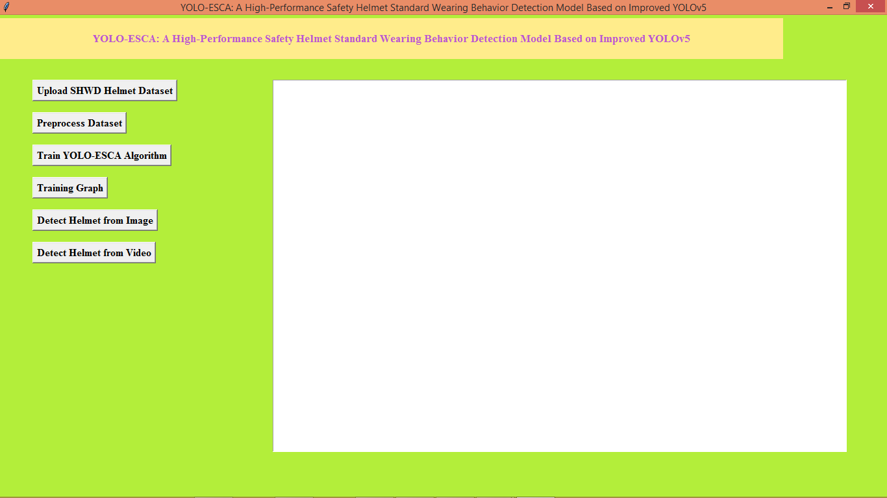
In above screen click on ‘Upload SHWD Helmet Dataset’ button to load dataset and then will get below page
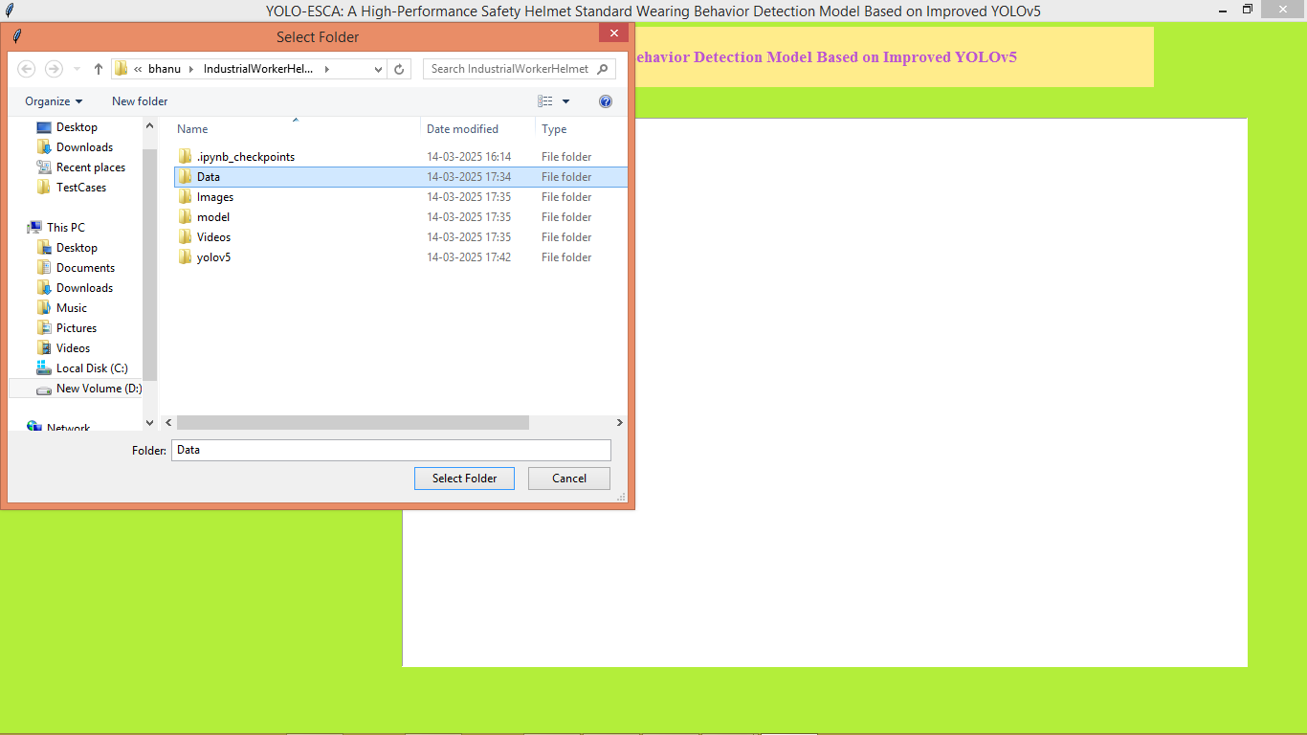
In above screen selecting and uploading ‘Data’ dataset folder and then click on ‘Select Folder’ button to load dataset and then will get below page
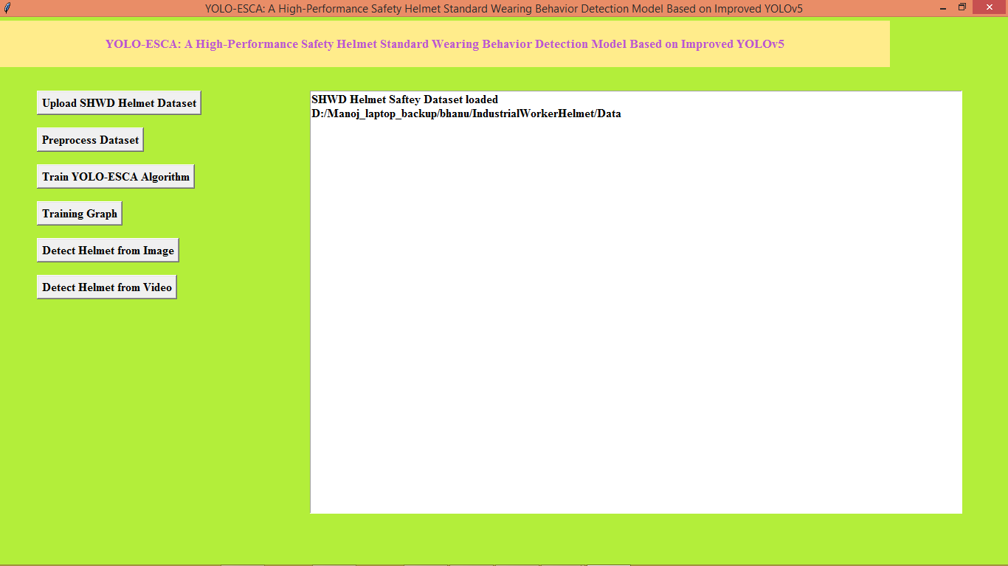
In above screen dataset loaded and now click on ‘Pre-process Dataset’ button to process dataset and then will get below page
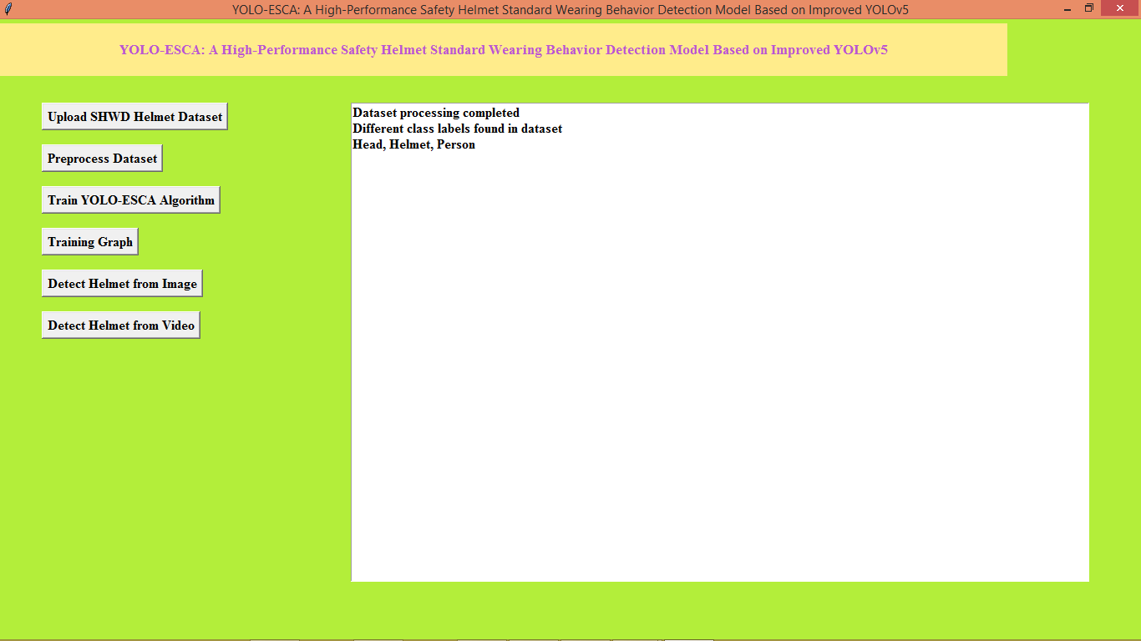
In above screen dataset processing completed and now click on ‘Train YOLO-ESCA Algorithm’ button to train model and then will get below page
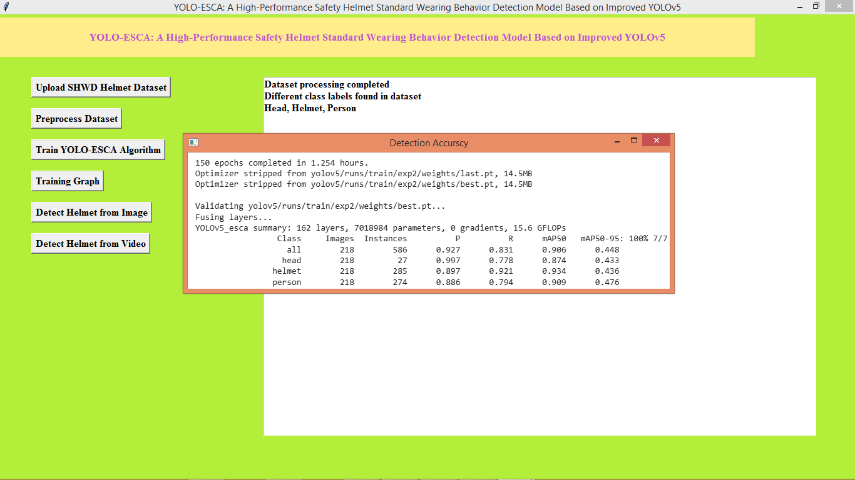
In above screen can see model prediction precision, recall values for each class label prediction and now click on ‘Training Graph’ link to get below page
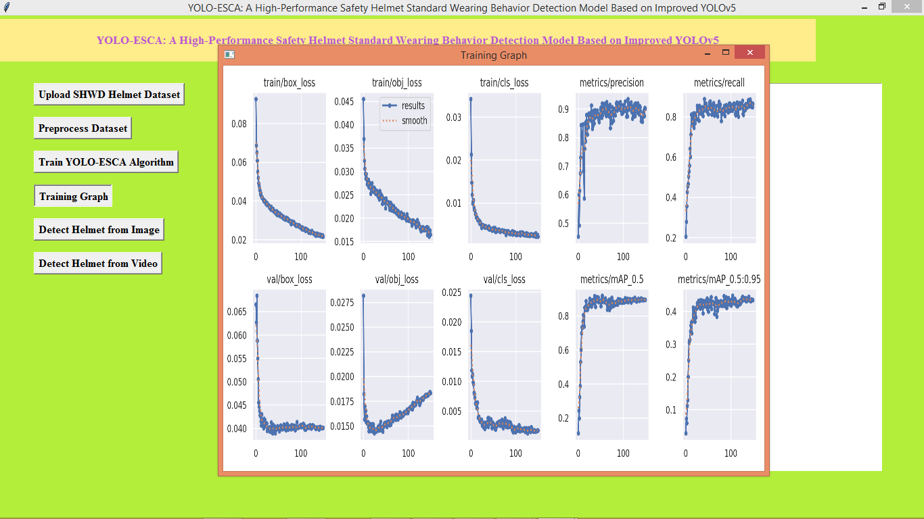
In above graph x-axis represents number of training epochs and y-axis represents precision and loss values and in each graph with increasing epoch precision and recall got increased and loss got decreased. Now click on ‘Detect Helmet from Image’ button to upload test image and then will get below page
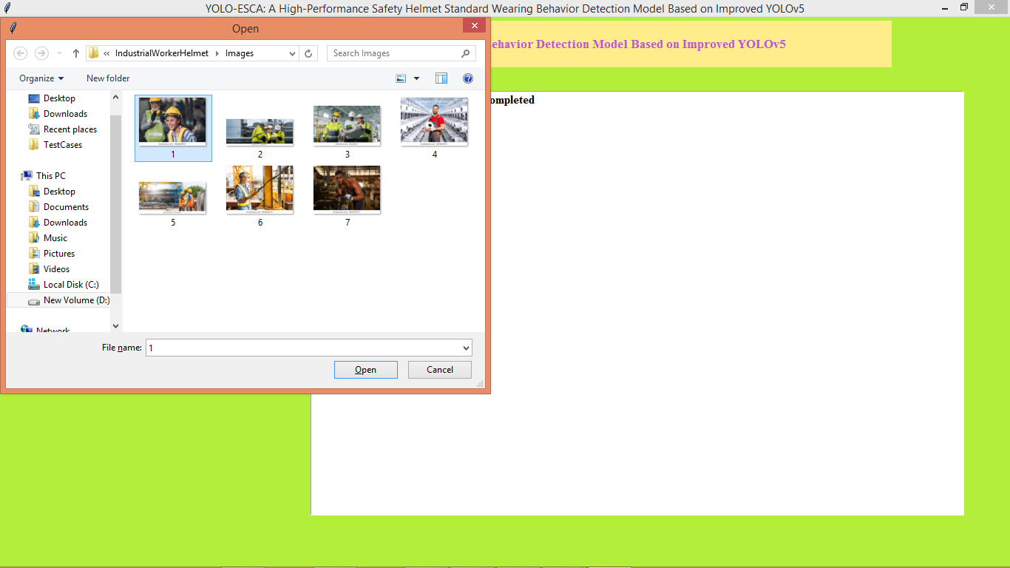
In above screen selecting and uploading image and then press ‘open’ button to get below page
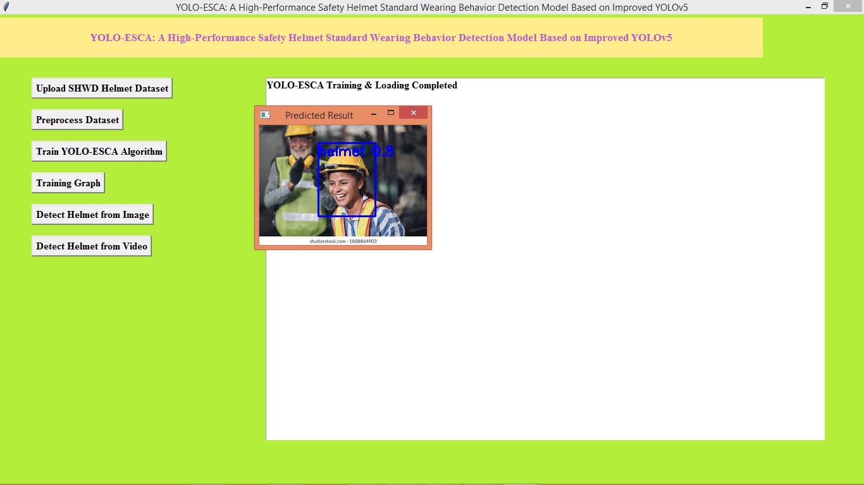
In above screen helmet detected and similarly you can upload and test other images
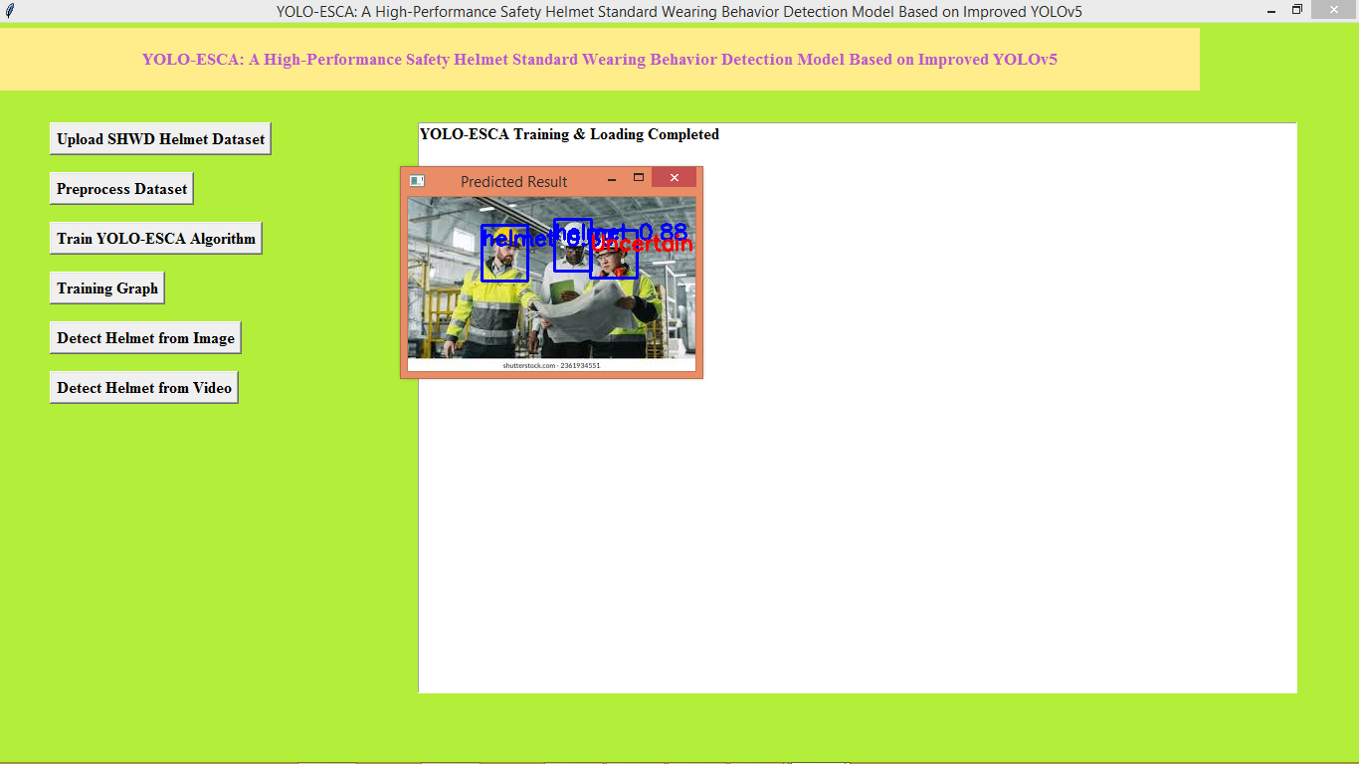
In above screen helmet detected and one helmet with uncertainty. Now click on ‘Detect Helmet from Videos’ button to get below page
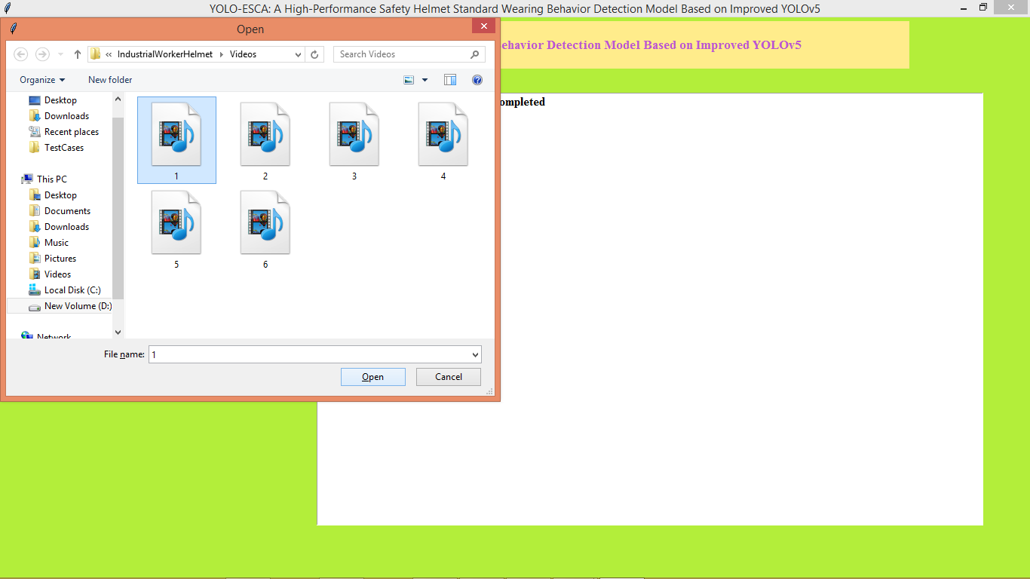
In above screen selecting and uploading video file and then press button to gtet below page
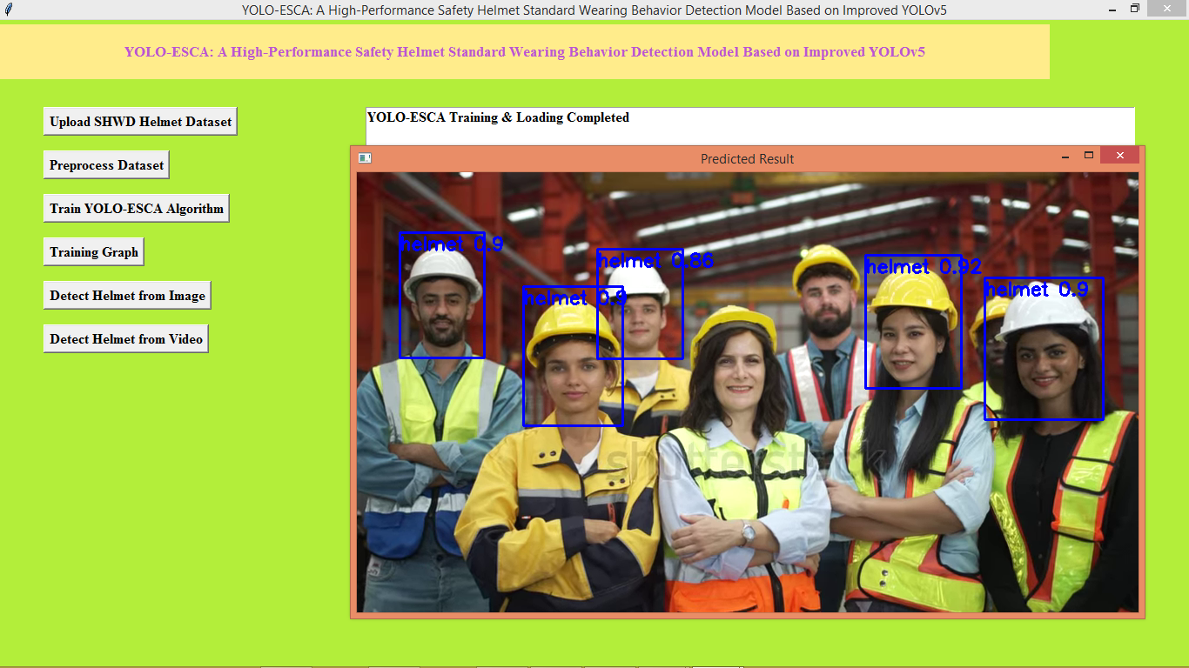
In above screen from video helmet start detection and similarly you can upload and test other videos
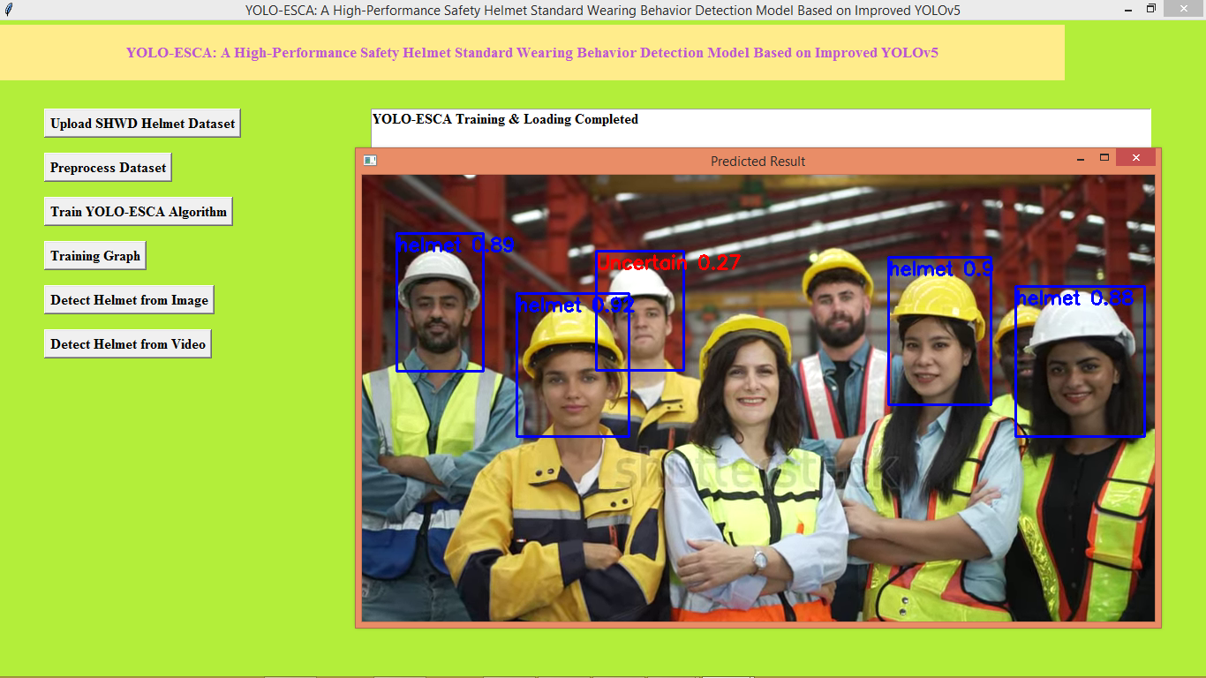
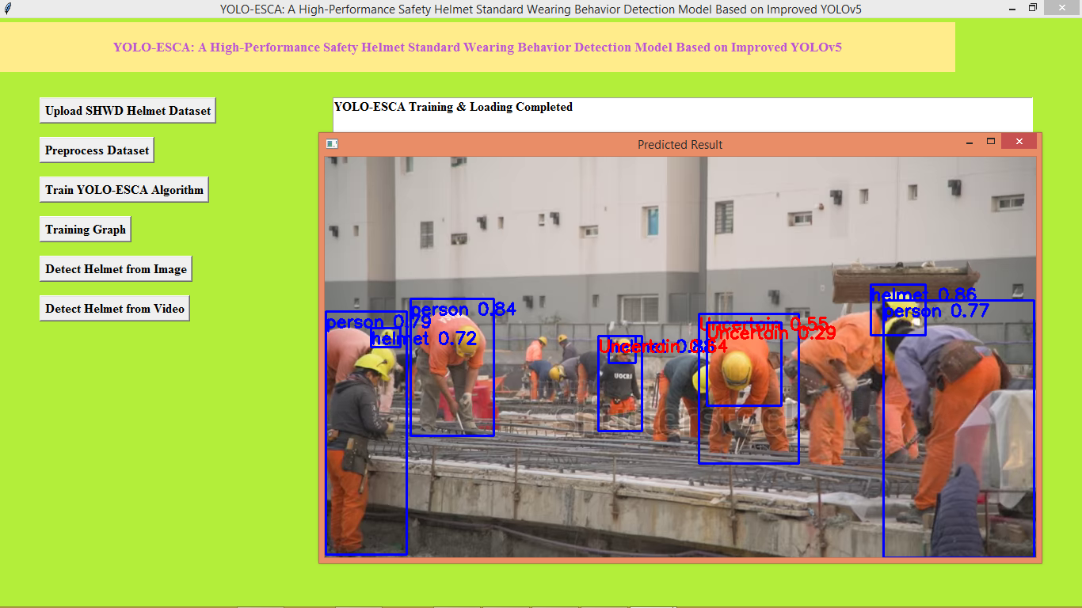
In above screen can see output from other videos
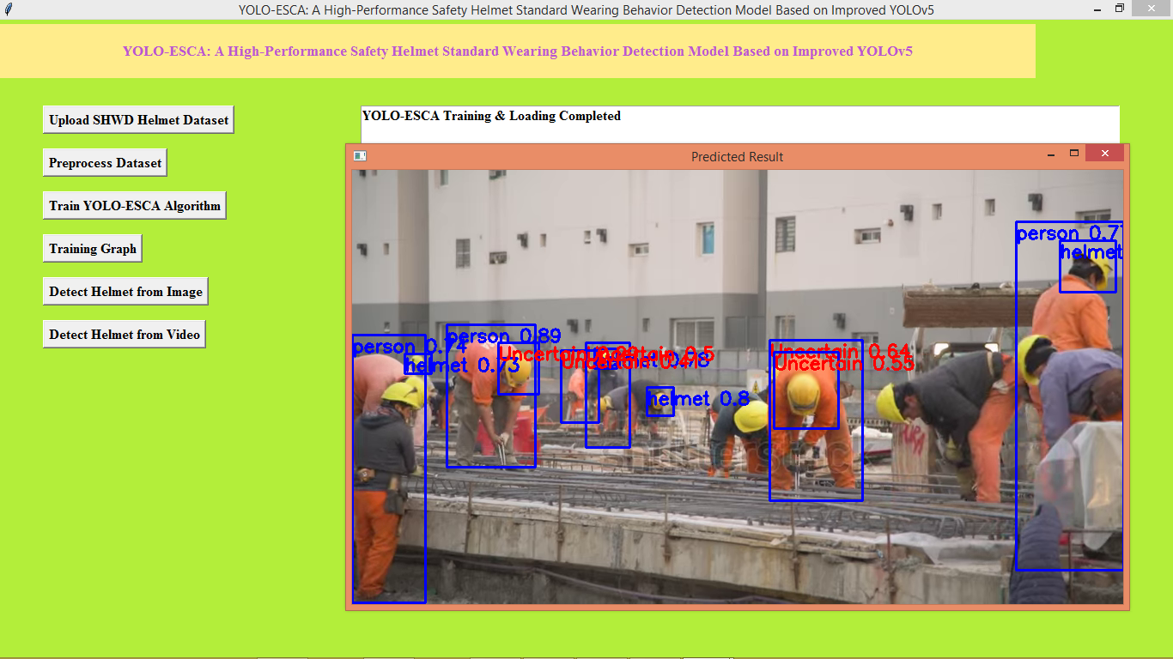
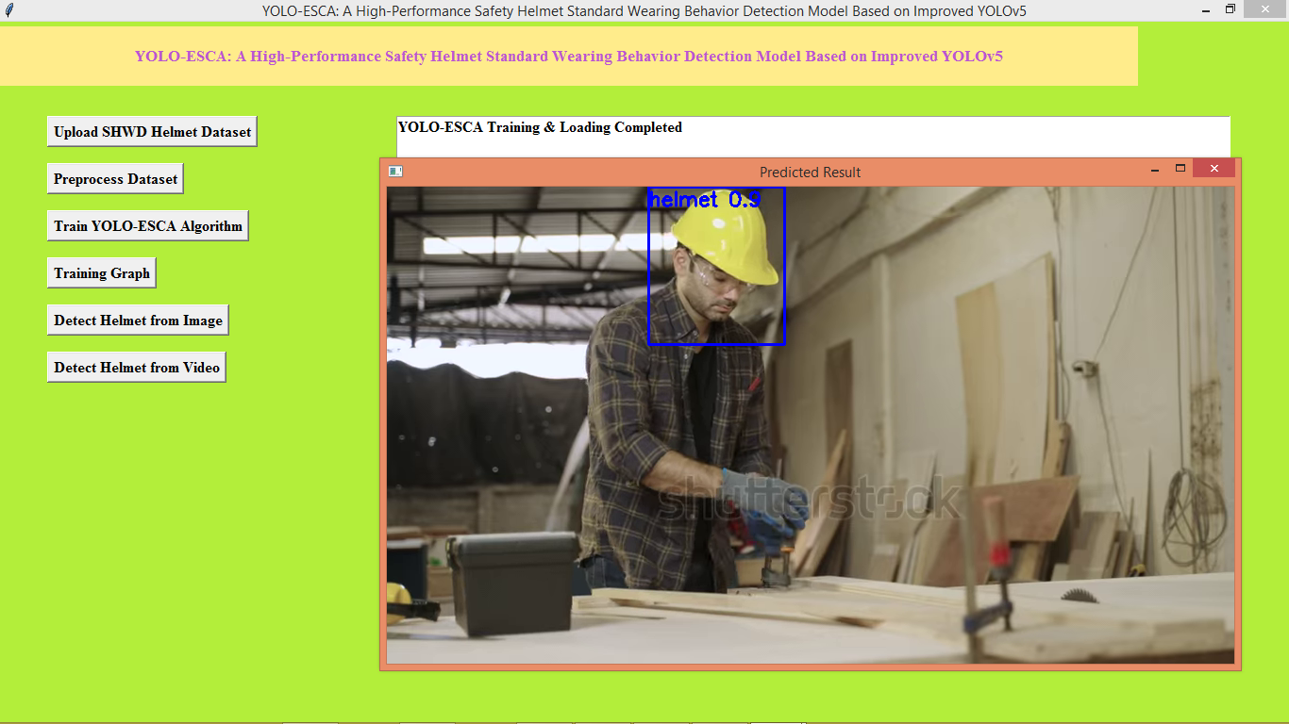
In above screen can see output from other video

8. CONCLUSION
In this study, we introduced YOLO-ESCA, a high-performance safety helmet standard wearing behavior detection model based on an improved YOLOv5 architecture. The development of YOLO-ESCA addresses critical challenges faced in real-time safety helmet detection, such as occlusions, varying environmental conditions, and worker pose variations in industrial settings. By enhancing YOLOv5, which is already known for its speed and accuracy in object detection, we have tailored the model to detect helmet-wearing behaviors with higher precision and reliability, even under difficult circumstances.
The modifications made to YOLOv5 include improvements in feature extraction, network architecture, and training strategies, all of which were designed to boost the model's performance in detecting safety helmets in dynamic environments. These improvements are particularly important in industrial settings, where safety helmets are critical for worker protection but can often be partially obscured, or workers' poses may vary due to movement or other safety gear.
Experimental results demonstrate that YOLO-ESCA outperforms traditional detection models in terms of detection accuracy, processing speed, and robustness to challenging environmental factors such as low light, background clutter, and occlusions. The model's ability to operate in real-time while maintaining high accuracy makes it suitable for large-scale deployment in industrial applications, including construction sites, manufacturing plants, and mining operations, where continuous monitoring of safety compliance is necessary.
The introduction of YOLO-ESCA also highlights the potential of AI and computer vision in improving workplace safety. By automating the detection of helmet-wearing behaviors, YOLO-ESCA provides an efficient and scalable solution for monitoring worker safety without relying on manual checks, reducing the likelihood of human error and ensuring continuous adherence to safety standards.
Additionally, YOLO-ESCA can be easily adapted to different industrial environments, providing flexibility and scalability for diverse applications. The model can be integrated into surveillance systems to monitor worker safety across various work sites, further enhancing compliance with safety regulations.
Future work will involve refining the model further by incorporating additional PPE detection and expanding its capability to recognize a wider range of safety behaviors in real-time. Furthermore, additional research could explore the integration of other AI-driven safety monitoring tools, such as fall detection or hazard identification systems, to create a comprehensive safety management solution.
In conclusion, YOLO-ESCA represents a significant advancement in the use of AI for workplace safety, offering a powerful tool for automated helmet detection and behavior monitoring. Through continuous improvements in model performance and adaptability, YOLO-ESCA promises to contribute to the reduction of workplace injuries and fatalities, ensuring a safer and more compliant working environment for all.
9.References
[1] I. S. Ahmad, A. A. Bakar, M. R. Yaakub and S. H. Muhammad, "A Survey on Machine Learning Techniques in Movie Revenue Prediction," SN Computer Science, p. 235, 2020.
[2] R. Sharda and D. Delen, "Predicting box-office success of motion pictures with neural networks," Expert Systems with Applications, vol. 30 , no. 2, p. 243–254, 2006.
[3] S. Wei, X. Zheng, D. Chen and C. Chen, "A hybrid approach for movie recommendation via tags and ratings," Electronic Commerce Research and Applications, vol. 18, pp. 83 - 94, 2016.
[4] X. (. Wang, J. H. (. Ryoo, N. Bendle and P. K. Kopalle, "The role of machine learning analytics and metrics in retailing research," Journal of Retailing, 2020.
[5] S. M. R. Abidi, Y. Xu, J. Ni, X. Wang and W. Zhang, "Popularity prediction of movies: from statistical," Multimedia Tools and Applications, pp. 47-48, 2020.
[6] I. S. Ahmad, A. A. Bakar and M. R. Yaakub, "Movie Revenue Prediction Based on Purchase Intention Mining," Information Processing and Management, vol. 57, no. 5, 2020.
[7] M. T. Lash and K. Zaho, "Early Prediction of Movie Success: The Who, What and When of Profitability," Journal of Management Information Systems, vol. 33, no. 3, pp. 874 - 952, 2016.
[8] H. Verma and G. Verma, "Prediction Model for Bollywood Movie Success: A Comparative Analysis of Performance of Supervised Machine Learning Algorithms," The Review of Socionetwork Strategies, 2019.
[9] S. Mundra, A. Dhingra, A. Kapur and D. Joshi, "Prediction of a Movie’s Success Using," in Information and Communication Technology for Intelligent Systems, Singapore, 2019.
[10] R. Parimi and D. Caragea, "Pre-release Box-Office Success Prediction for Motion Pictures," Machine Learning and Data Mining in Pattern Recognition, vol. 7988, pp. 571-585, 2013.
[11] K. Lee, J. Park, I. Kim and Y. Choi, "Predicting movie success with machine learning techniques: ways to improve accuracy," Information Systems Frontiers, vol. 20, pp. 577-588, 2018.
[12] S. Anunaya, "Data Preprocessing in Data Mining -A Hands On Guide," 10 08 2021. [Online]. Available: https://www.analyticsvidhya.com/blog/2021/08/datapreprocessing-in-data-mining-a-hands-on-guide/. [Accessed 12 08 2021].
[13] J. Browniee, "How to Perform Feature Selection With Numerical Input Data," 18 08 2020. [Online]. Available: https://machinelearningmastery.com/feature-selectionwith-numerical-input-data/. [Accessed 21 05 2021].
[14] J. Brownlee, "A Gentle Introduction to the Chi-Squared Test for Machine Learning," 31 10 2019. [Online]. Available: https://machinelearningmastery.com/chisquared-test-for-machine-learning/. [Accessed 21 05 2021]
[15] J. Brownlee, "How to Choose a Feature Selection Method For Machine Learning," 27 11 2019. [Online]. Available: https://machinelearningmastery.com/feature-selectionwith-real-and-categorical-data/. [Accessed 19 03 2021].

